**Unit Review: Forces and Motion**

**Read each question. Circle the letter of the correct answer.**

**1.** What is a force?

**A.** a pull exerted on an object

**B.** a measure of how heavy an object is

**C.** a push or a pull exerted on an object

**D.** a change in the direction of motion of an object

**2.** Sasha pulls a block across the floor at a constant speed. Why doesn’t the motion of the block change even though Sasha is pulling on it?

**A.** Sasha’s force on the block is balanced by the friction force.

**B.** Sasha’s force on the block is balanced by the gravitational force.

**C.** If Sasha was not pulling on the block, there would be no forces on the block, and it would speed up.

**D.** If Sasha was not pulling on the block, there would be no forces on the block, and it would stop moving.

**3.** When a comet enters the solar system, it curves toward the sun. Which statement describes why the sun does not move when a comet is nearby?

**A.** There is no force exerted on the sun from the comet.

**B.** There is no force exerted on the sun unless the sun and comet collide.

**C.** The force on the sun from the comet is smaller than the force on the comet from the sun because the comet’s speed is too great.

**D.** The force on the sun from the comet is equal to the force on the comet from the sun but does not cause the sun to move because the sun is too massive.

**4.** The weights of four objects with different masses have been calculated to show how much each object would weigh on four different planets.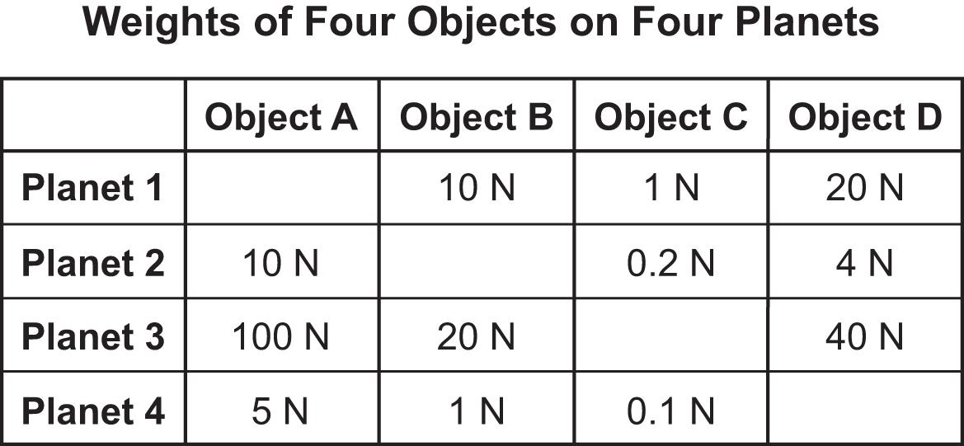

Based on the table, which object would have the largest mass and greatest weight on Earth?

**A.** object A

**B.** object B

**C.** object C

**D.** object D

**5.** Rebecca is practicing her aim by throwing a ball at a target.

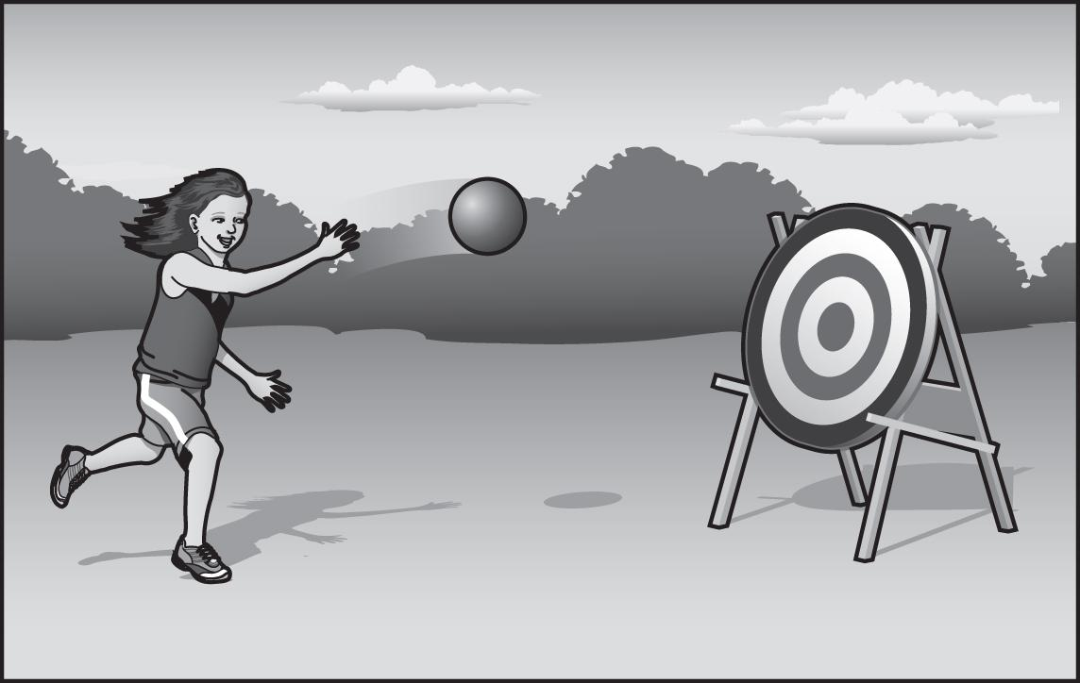

The ball exerts a force on the target, causing the target to fall over. But when this happens, the ball bounces backward. Why does the ball bounce backward?

**A.** The target exerts a larger force on the ball because the ball is very bouncy.

**B.** The ball exerts a larger force on the target, causing the target to have a larger change of motion than the ball.

**C.** The target exerts the same size force on the ball, so when the target moves in one direction, the ball moves in the opposite direction.

**D.** The ball exerts a smaller force on the target because the ball is smaller than the target, so the target causes the ball to bounce backward.

**6.** The diagram shows four blocks suspended on identical dynamometers, a tool that is used for measuring the weights of objects.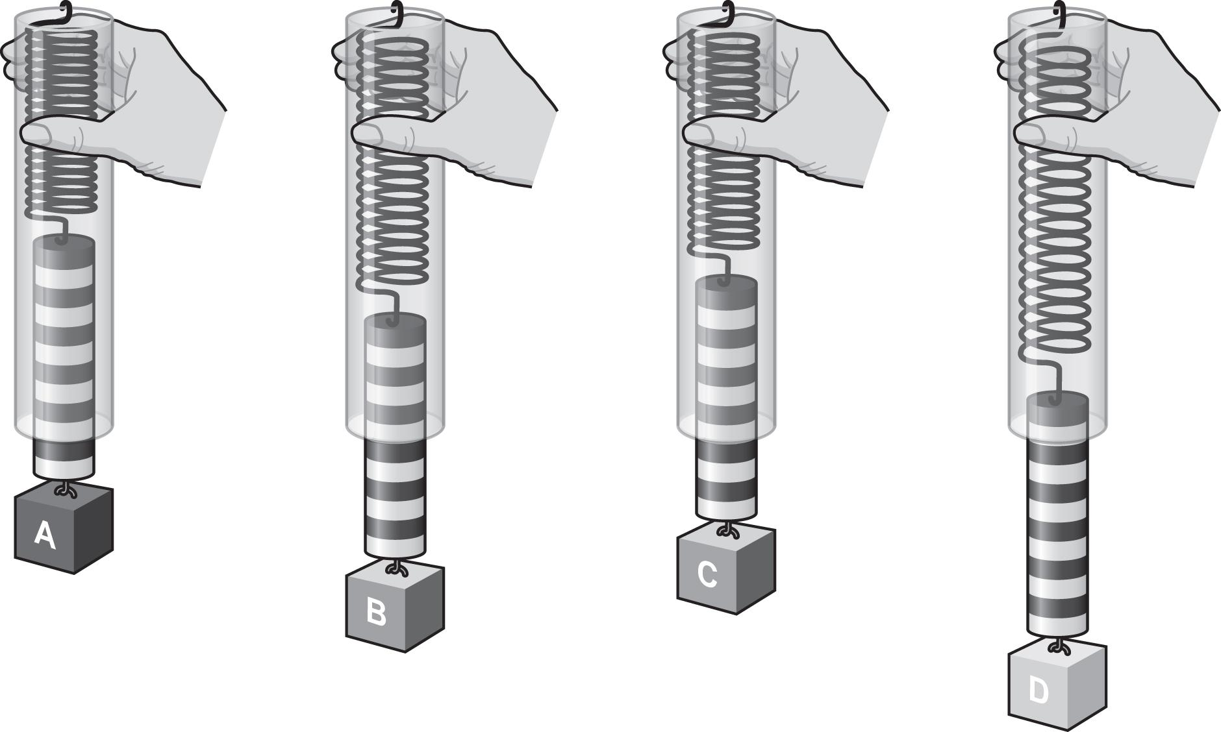

Which object has the greatest weight?

**A.** object A

**B.** object B

**C.** object C

**D.** object D

**7.** Two cars travel on a straight road from point A to point B. Both cars accelerate to their maximum speed and then continue at that speed for the rest of the distance. Car 1 accelerates from rest to 20 m/s over 30 s. It reaches point B in 35 s. Car 2 accelerates from rest to 20 m/s over 20 s. It reaches point B in 30 s. Which car uses a larger acceleration to reach its maximum speed, and which car has a larger average speed?

**A.** Car 1 has both a larger acceleration and a larger average speed.

**B.** Car 2 has both a larger acceleration and a larger average speed.

**C.** Car 1 has a larger acceleration, but Car 2 has a larger average speed.

**D.** Car 2 has a larger acceleration, but Car 1 has a larger average speed.

**Read each question. Follow the instructions to answer the questions.**

**8.** Chini is sliding blocks of different materials down a steel ramp. All of the blocks have similar sizes and masses. The table shows the coefficient of friction for several materials when sliding on steel. The larger the coefficient of friction, the greater the force of friction. In which order would the blocks reach the bottom of the ramp?

Number the materials from 1 to 5 with 1 as the material that will slide down the ramp the fastest and 5 as the material that will slide down the ramp the slowest.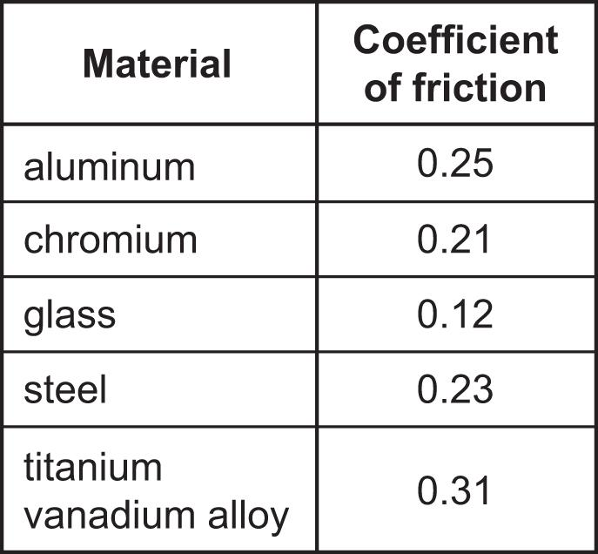

__________ aluminum

__________ chromium

__________ glass

__________ steel

__________ titanium vanadium alloy

**9.** Write an X in the correct box for each statement to show whether each force is a contact force or a noncontact force.

| **Forces** | **Contact** | **Noncontact** |
| --- | --- | --- |
| **A.** gravity |  |  |
| **B.** friction |  |  |
| **C.** air resistance |  |  |
| **D.** magnetic force |  |  |
| **E.** pushing with your hands |  |  |

**10.** The arrows in the force diagrams represent the various forces acting on a box. The box starts out at rest.

Which diagrams match the descriptions? Write the letters of the diagrams in the correct boxes. Some boxes may contain more than one letter.

| **Starts moving to the left** | **Starts moving to the right** | **Stays at rest** |
| --- | --- | --- |
|  |  |  |

**A. 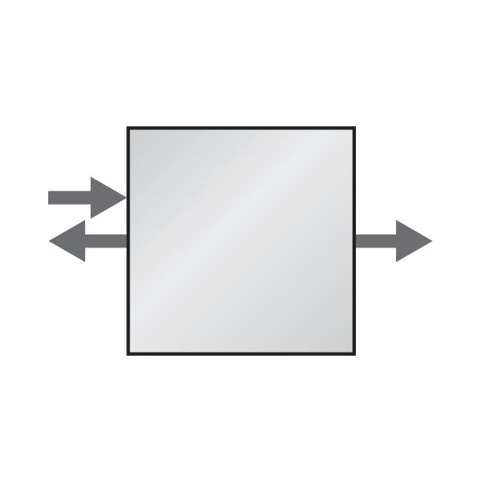 B. 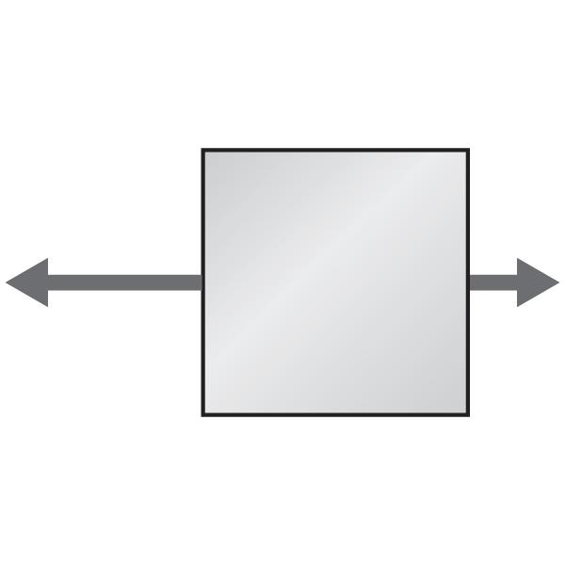 C.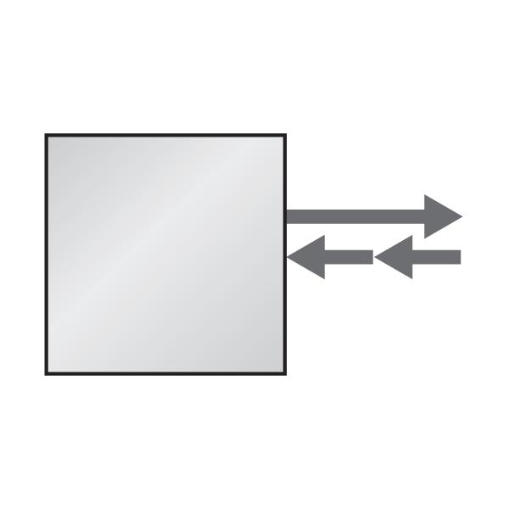 D.**